
Solution Architecture

Date | 13 July 2026
Team ID | xxxxxx
Project Name | Personalized Networking Assistant
Maximum Marks | 5 Marks

Solution Architecture Diagram:

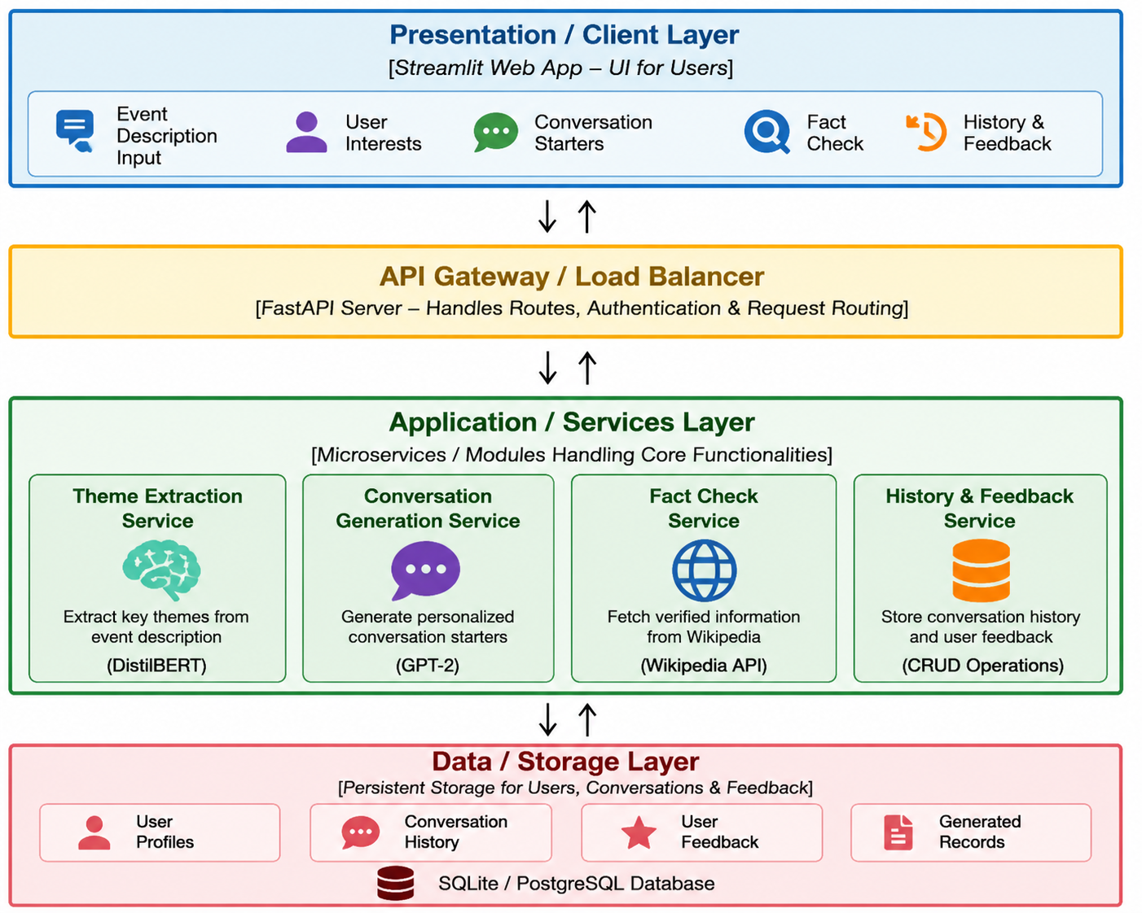



Component Description Table

Component Name | Description / Role in Architecture | Technologies Used
Presentation Layer | Provides an interactive web interface where users enter event descriptions, interests, perform fact checks, view conversation history, and submit feedback. | Streamlit, HTML, CSS
API Gateway | Receives requests from the frontend, routes them to appropriate backend services, validates requests, and returns responses to the user. | FastAPI, Uvicorn
Microservices | Performs theme extraction using DistilBERT, generates personalized conversation starters using GPT-2, retrieves fact summaries from Wikipedia API, and manages conversation history and feedback. | Python, Transformers (DistilBERT & GPT-2), Wikipedia API
Database | Stores user conversation history, generated conversation starters, and user feedback for future personalization and retrieval. | SQLite / PostgreSQL

